DATABASE SYSTEMS ENGINEERING AND DISTRIBUTED BACKEND DEVELOPMENT

TOPIC: DDL, DML, DCL, TCL COMMANDS

2520030371 – P. HAVISHAA REDDY

QUESTION 1 - CREATE TABLE:
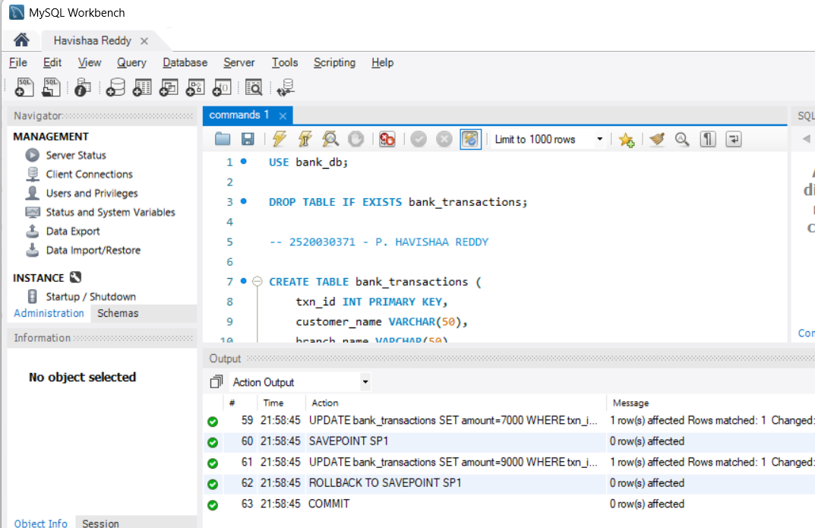

QUESTION 2 - ALTER TABLE ADD COLUMN

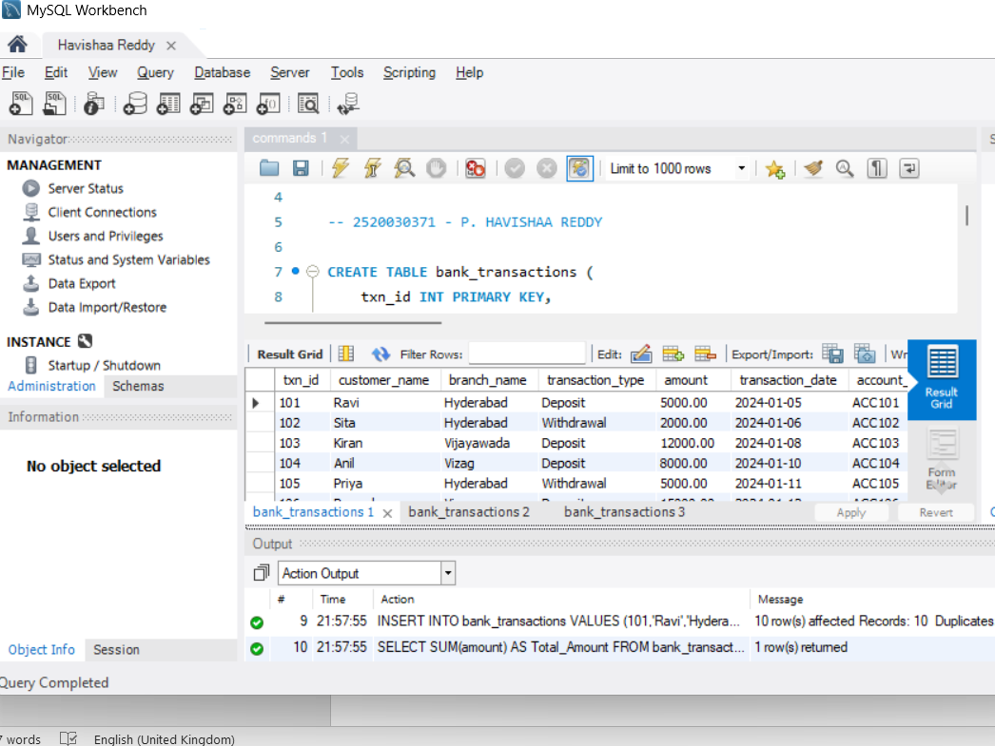

QUESTION 3 - ALTER TABLE MODIFY COLUMN
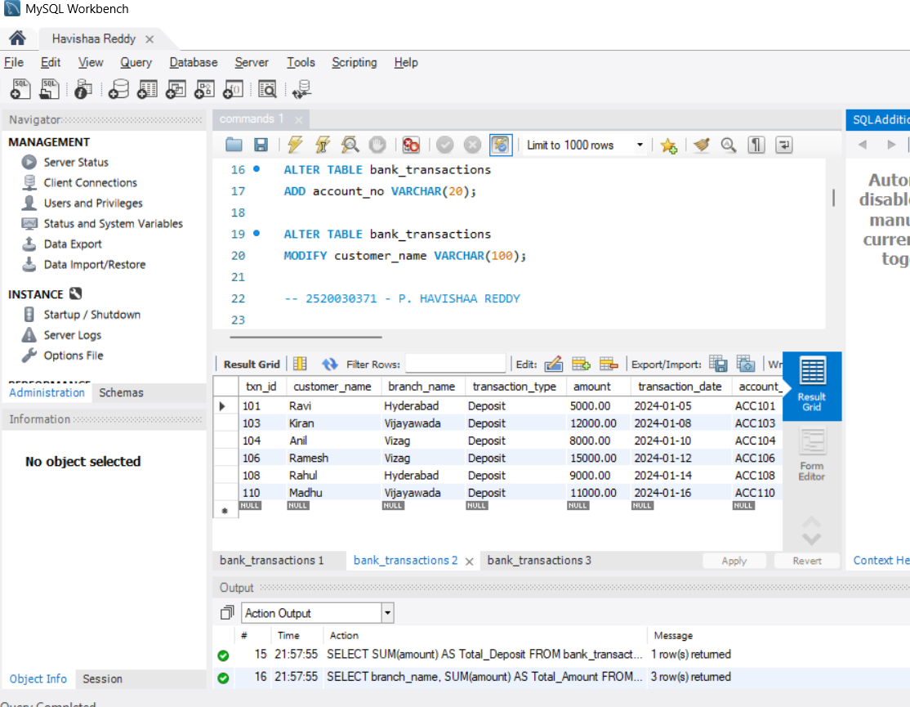

QUESTION 4 - RENAME TABLE
